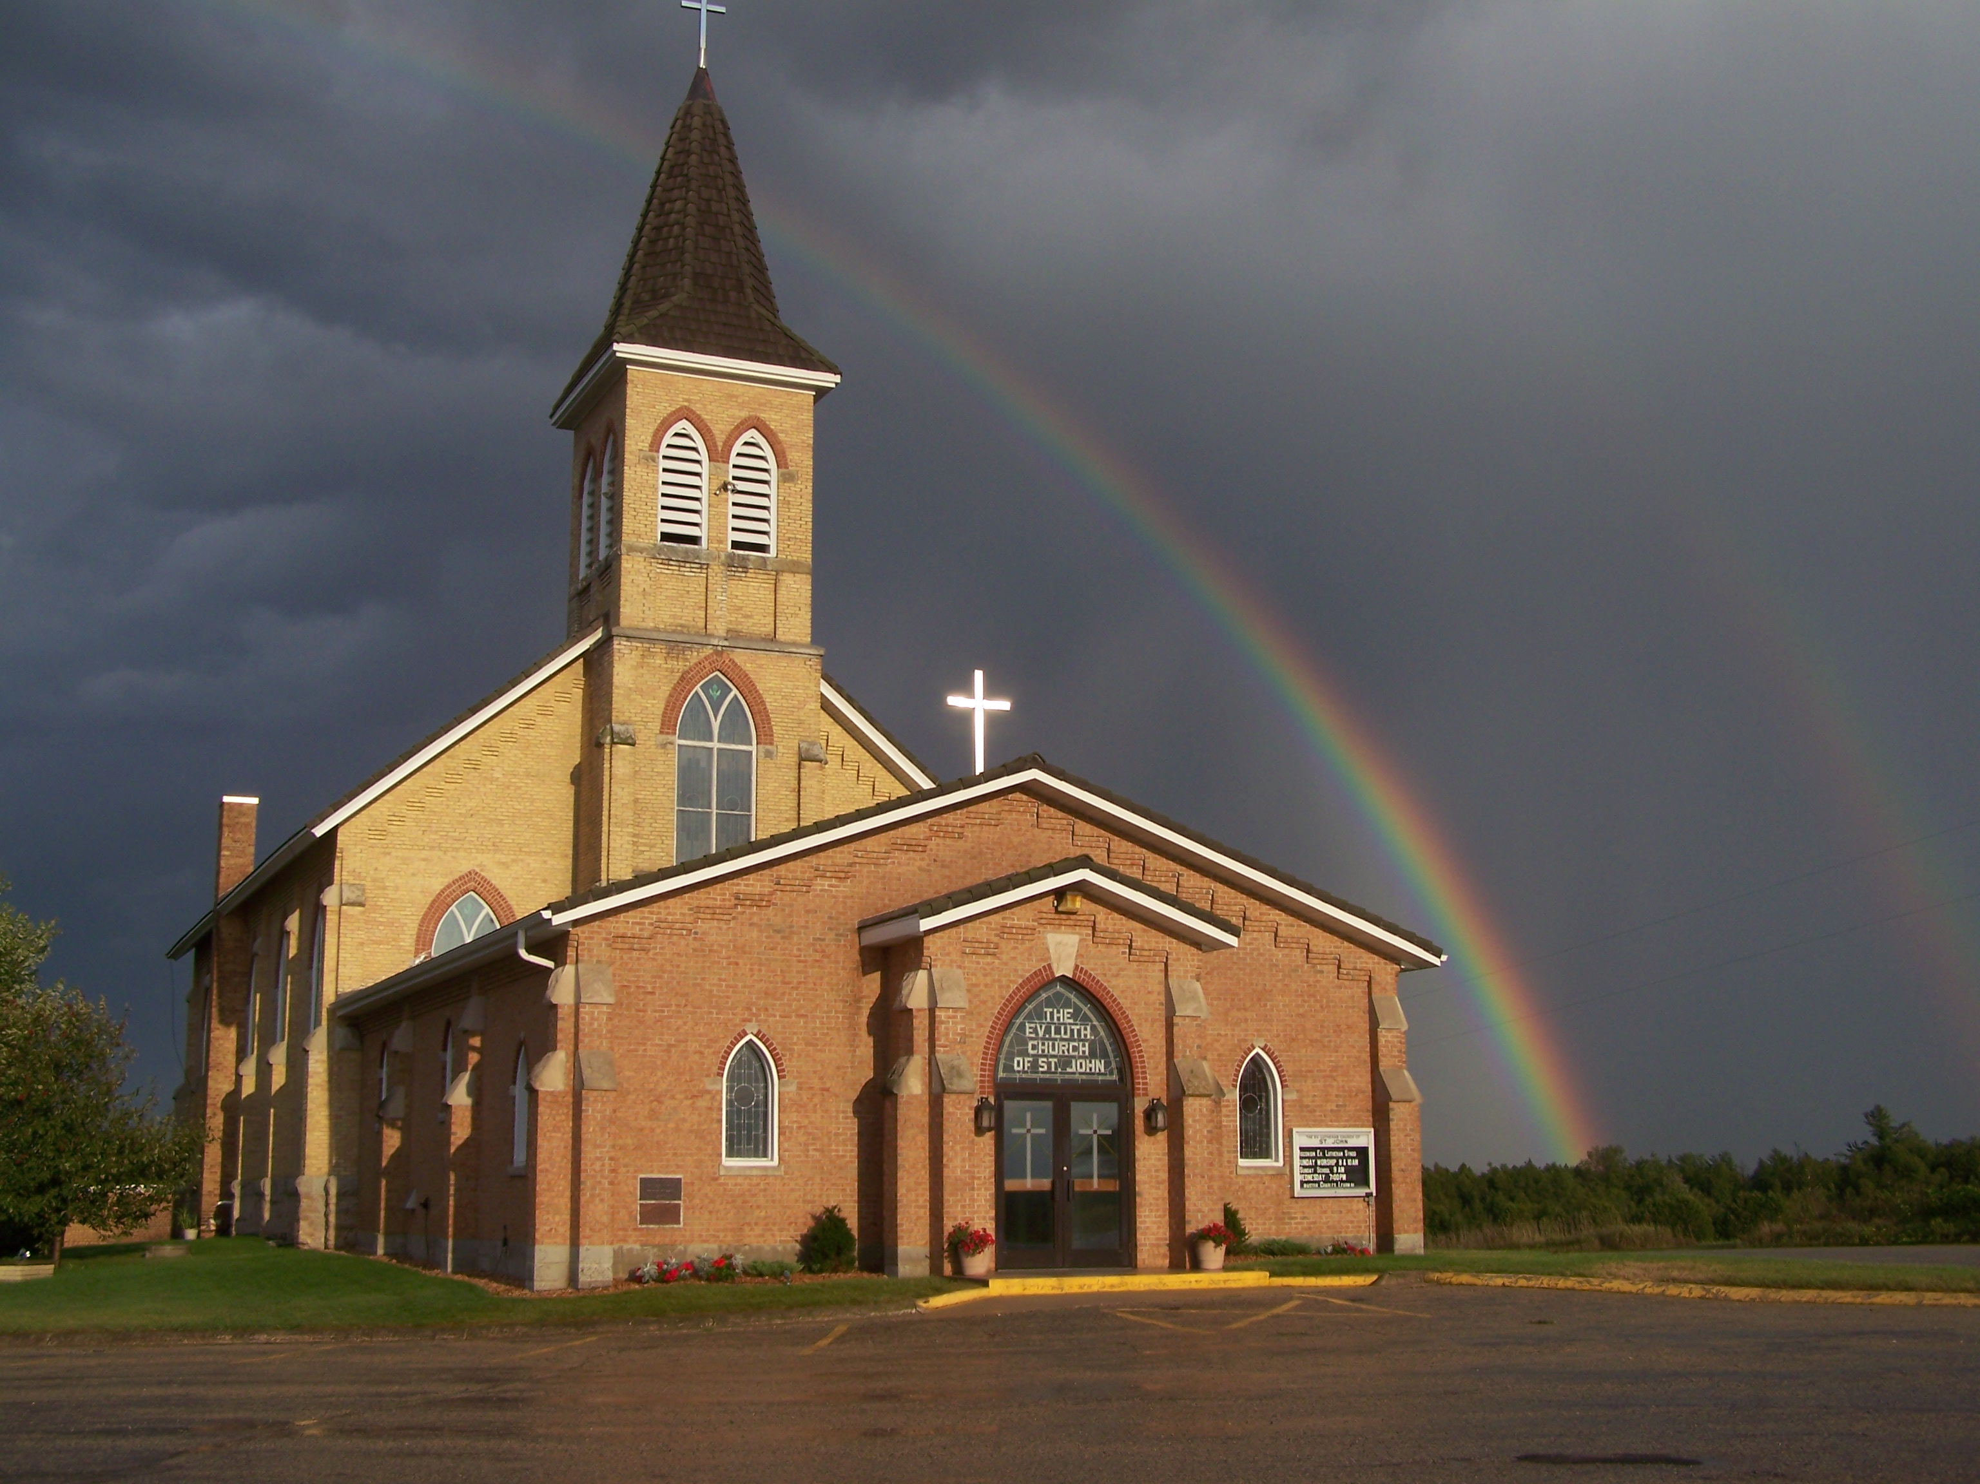
The Evangelical Lutheran Church of St. John
N1916 Church Road
Peshtigo, Wisconsin 54157-9673
Pastor Sargent 920-228-1061

01/25/2021

Dear members of St. John,



Our son Nathan has recovered and is cleared from quarantine. Lisa and I do not seem to have symptoms and are scheduled for a test today. If we receive a negative test, we will be out of quarantine on January 30. Arrangements have been made with Pastor Larry Nast to take services on the 31st if we are positive, but we pray we are not. We would like to thank all of those who have sent cards and well wishes. We are also thankful for all those who have offered and provided help in getting things for us during the quarantine and especially for all the prayers. We know that God does provide!

Yours’s in Jesus care,

Pastor Sargent,
Lisa and Nathan

Important Information:

Bible Study:

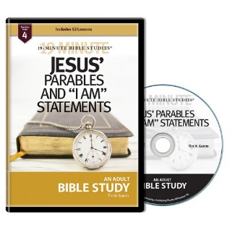
The next Bible Study is called Jesus’ Parables and the “I am Statements” Copies of the first lesson are available from the ushers at church and can be found on the church webpage www.stjohnpeshtigo.org in the News Letter section. The first lesson will be posted on our YouTube page on Saturday February 6. Please join us for this 19 Minute study where we will visit with Jesus and look at his “I Am” Statements and Parables. The first lesson is titled. “Jesus’ Body as the Temple” (John 2:13-22)

Sunday School:



Attention Parents!

We are in the Winter Lessons Schedule. The Lesson for Sunday February 7 is The Centurian’s Faith found in Matthew 8 and Luke 7. Please let your Sunday School Teacher or Pastor know if you are having any trouble getting the lessons. We know this is a difficult time because of the pandemic. As of now, we are not able to hold in-person classes. We are very concerned about Sunday School want to make sure parents and children are getting the lessons they need. If you have any questions or concerns you can also call Pastor Sargent (920) 228-1061.

Click on https://online.nph.net/ss-remote
to view the videos.

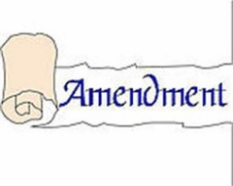
Constitution/By-Law Amendment:

The Church Council has recommended an amendment to Article 9 “The Board of Education.” It will be presented for a vote at the Annual Voters Meeting on January 31. The wording to be added to the article is as follows:

“Up to two seats on the five-member board of education may be filled by members of area churches whom we share fellowship and have children in the St. John school. Those outside board of education members have a vote on the board of education, but do not have a vote on the full church council nor are they voting members of St. John Church. Any board of education candidate from another congregation shall be elected at a meeting of the voting members of St. John. Additionally, up to two non-voting advisory members of the board of education may be appointed by the church council. Those advisory positions may be filled by St. John members or members from our fellowship congregations."

Worship: If you are not feeling well or have concerns about your own health, you do not need to attend. We will continue with the Livestreaming service at 8:30. If you would like to receive private communion at home please contact Pastor Sargent.

http://www.facebook.com/The-Evangelical-Lutheran-Church-of-St-John-Town-of-Grover-WELS-100389558275581/
https://www.youtube.com/channel/UCJ8tkCadzLHuxGWLhovgl8Q
Pastor Daniel Sargent

